GeoDT User Guide
Dr. Luke P. Frash, Los Alamos National Laboratory
This guide explains model setup and payoff interpretation for Geothermal Design Tool (GeoDT) and Geothermal Design Tool Interactive (GeoDTi). Please note this is a working document and therefore subject to change. Feedback and questions are appreciated.

Overview
The interactive panel for GeoDT 4.X provides the most commonly used controls to setup, run, and inspect the outcomes for conceptual designs for geothermal reservoir development (Figure 1). The layout is intended for rapid iteration to help you to refine your development strategy. Complete the following steps to get started. Note that the most common first-run errors tend to be incompatible python libraries or conflicts with security software, so check for those issues first. We use Anaconda 3.X to execute our core code.

GeoDTi First Run
- Select “Import Scenario” – load model setups from comma delimited files (*.gts)
- Select “DEFAULT.gts” – contains default ranges for model parameters (FULL.gts is more broad)
- Select “Run Batch” – save your settings and launch GeoDT to run in an external window
- Select “Refresh Statplot” – loads batch run results and apply model settings as a filter
- Right click to select a result from the scatter plot – loads the data from that run
- Explore, edit, and iterate – use GeoDTi to design, optimize, and learn
- Bold text in the setup explorer – an indicator for active filters, modify filters by changing values
- Dropdown menus – modify the content of the plots to view results in different ways
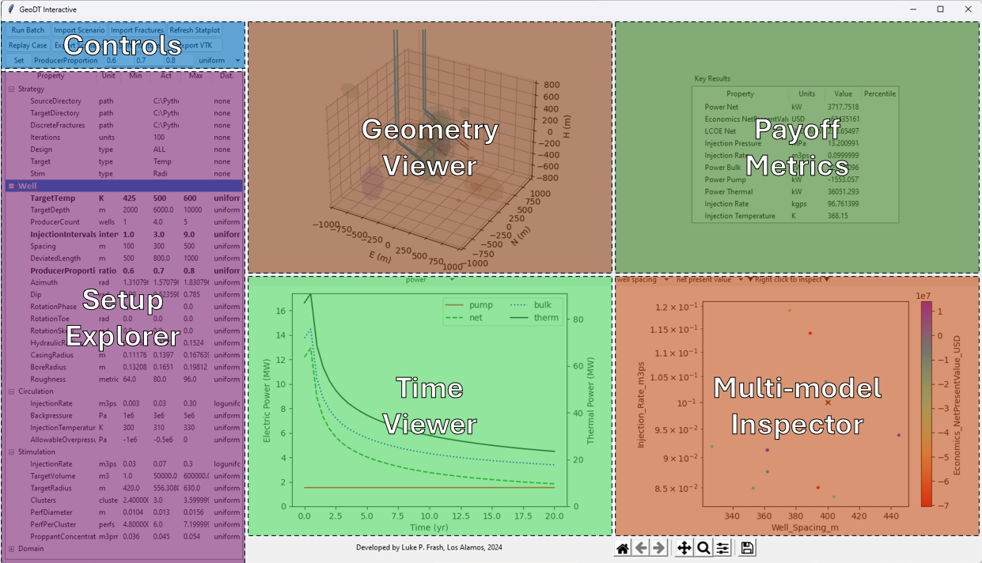
Figure 1: Layout for GeoDT for iterative geothermal reservoir design and optimization.

GeoDT First Run
- Load and run “GeoDT_standard” – launch GeoDT’s solvers
- Select “DEFAULT.gts” – a comma delimited text file containing model setup information
- Load and run “GeoDT_3Dvis” – creates *.vtk graphics files that can be viewed with ParaView
- View “############_@@@@@.vtk” – graphics files containing simulation results
- View “setup_payoff.csv” – comma delimited summary of simulation inputs and outputs
- Edit “DEFAULT.gts” – modify model inputs to simulate new scenarios
- Advanced use – view and edit the source files to access more advanced features

Model Setup
GeoDTi includes a multitude of physical processes that are meant to approximate the complexity of deep geothermal systems, but without requiring detailed knowledge about the specific site. This is made possible by our database of general rock properties (Table 1). When details are unknown for a site, we recommend using broad uncertainty ranges to assess the full range of possibilities. To do this, subject matter expertise is useful to identify reasonable first assumptions. Otherwise, GeoDT’s default values can be used and then the results then explored to identify important details. In this way, GeoDTi is designed to be used for hypothesis testing and learning, in addition to quantitative performance analysis.

File Types
The setup files (e.g. DEFAULT.gts) detail batch run model configurations with input randomizers. The results files (e.g., setup_payoff.csv) include all the inputs that a given simulation used as it was executed alongside the key results from that simulation. Replay files (e.g., 123456789.geodt) are a python pickle file that stores detailed information from within each simulation run, such as nodal temperature data as a function of time. Scripts are included to provide examples for how to load and manipulate the replay files for post-processing. This functionality is best reserved for advanced Python users.

Overview of Model Parameters
Table 1: Description of model inputs and outputs for GeoDTi.
Family | Property | Units | Description
Strategy | SourceDirectory | path | directory for instance of GeoDT
Strategy | TargetDirectory | path | directory for results
Strategy | DiscreteFractures | path | input file for predefined fracture placement
Strategy | Iterations | units | number of simulations to model
Strategy | Design | type | drilling and stimulation strategy
Strategy | Target | type | drilling target strategy - desired depth or temperature
Strategy | Stim | type | stimulation strategy - by volume or fracture radius
Well | TargetTemp | K | target reservoir temperature (used if Strategy_Target_type == TEMP)
Well | TargetDepth | m | target reservoir depth (used if Strategy_Target_type == DEEP)
Well | ProducerCount | wells | number of production wells
Well | Spacing | m | separation distance between parallel wells
Well | DeviatedLength | m | length of the deviated portion of the well
Well | ProducerProportion | ratio | ratio of the injection well's deviated lenth to the production wells
Well | Azimuth | rad | orientation of the injection well east of north
Well | Dip | rad | orientation of the injection well down from horizon
Well | RotationPhase | rad | orientaion of first production well CW from horizon around injector's axis
Well | RotationToe | rad | toe in of the production wells relative to the injector's axis
Well | RotationSkew | rad | out of plane skew of the well (used for spiral effect)
Well | HydraulicRadius | m | hydraulic radius of the wells (inner diameter)
Well | CasingRadius | m | outer radius of well casing (inner wall of cemented annulus)
Well | BoreRadius | m | drilled radius of the well (cutter radius)
Well | Roughness | metric | Hazen-Williams pipe roughness coefficient - lower is higher friction
Circulation | InjectionRate | m3/s | target volumetric flow rate of water per injection well during circulation
Stimulation | InjectionRate | m3/s | target volumetric flow rate of water per injection well during stimulation
Stimulation | TargetVolume | m3 | target injection volume during stimulation (used if Strategy_Stim_type == VOL)
Stimulation | TargetRadius | m | target stimulated fracture radius (used if Strategy_Stim_type == RAD)
Domain | Size | m | half-width of the modeling domain represented by six conductive fractures
Rock | ThermalGradient | K/m | rate of temperature increase with depth (i.e., geothermal gradient)
Rock | Density | kg/m3 | nominal density of rock from surface to reservoir (typically near 2500)
Rock | ThermalConductivity | W/mK | thermal conductivity of the reservoir rock (typically near 2.7)
Rock | HeatCapacity | kJ/m3K | specific heat capacity of the reservoir rock (typically near 2000)
Air | Temperature | K | ambient surface temperature
Air | Pressure | Pa | ambient surface pressure
Rock | YoungsModulus | Pa | uniaxial elastic modulus of reservoir rock (i.e., Young's modulus)
Rock | PoissonRatio | ratio | lateral to vertical deformation modulus (i.e., Poisson's ratio)
StressMin | Coefficient | ratio | vertical to minimum horizontal effective stress (i.e., Coulomb earth pressure)
StressMax | Coefficient | ratio | vertical to maximum horizontal effective stress (i.e., Coulomb earth pressure)
StressMin | Azimuth | rad | horizontal orientation of minimum principal stress east of north
StressMin | Dip | rad | orientation of the minimum principal stress down from horizion
StressMin | Variance | rad | variance of the orientation of minimum principal stress
Fracture | SlipLengthMin | ratio | ratio of shear slip displacement to fracture length
Fracture | SlipLengthNom | ratio | ratio of shear slip displacement to fracture length (nominally 0.01)
Fracture | SlipLengthMax | ratio | ratio of shear slip displacement to fracture length
Fracture | DilationSlipMin | ratio | ratio of aperture dilation to shear slip displacement
Fracture | DilationSlipNom | ratio | ratio of aperture dilation to shear slip displacement (nominally 0.2)
Fracture | DilationSlipMax | ratio | ratio of aperture dilation to shear slip displacement
Fracture | HydraulicDilationMin | ratio | ratio of hydraulic aperture to aperture dilation
Fracture | HydraulicDilationNom | ratio | ratio of hydraulic aperture to aperture dilation (nominally 0.6)
Fracture | HydraulicDilationMax | ratio | ratio of hydraulic aperture to aperture dilation
Fracture | CompressibilityMin | 1/Pa | fracture aperture compressibility as a function of normal stress
Fracture | CompressibilityNom | 1/Pa | fracture aperture compressibility as a function of normal stress (nominally 3e-8)
Fracture | CompressibilityMax | 1/Pa | fracture aperture compressibility as a function of normal stress
Proppant | CompressibilityMin | 1/Pa | proppant compressibility as a function of normal stress
Proppant | CompressibilityNom | 1/Pa | proppant compressibility as a function of normal stress (nominally 3e-8)
Proppant | CompressibilityMax | 1/Pa | proppant compressibility as a function of normal stress
Fracture | InitialHydraulicApertureMin | m | initial natural fracture hydraulic aperture
Fracture | InitialHydraulicApertureNom | m | initial natural fracture hydraulic aperture (nominally 0.0001)
Fracture | InitialHydraulicApertureMax | m | initial natural fracture hydraulic aperture
Domain | BoundaryAperture | m | hydraulic aperture of the model's domain boundaries that are treated as fractures
Fracture | TortuosityMin | ratio | aperture scaling coefficient to accommodate fracture complexity
Fracture | TortuosityNom | ratio | aperture scaling coefficient to accommodate fracture complexity (nominally 0.75)
Fracture | TortuosityMax | ratio | aperture scaling coefficient to accommodate fracture complexity
Cement | ThermalConductivity | W/mK | cement thermal conductivity (nominally 2.0)
Cement | HeatCapacity | kJ/m3K | cement voplumetric heat capacity (nominally 2000)
Power | GeneralEfficiency | ratio | general efficiency of thermal-electric machinery (nominally 0.85)
Power | LifeSpan | s | lifespan of the geothermal project (nominally 30 yr = 9.4673e8 s)
Domain | TimeSteps | steps | number of time steps for the heat transfer solver (nominally 30)
Circulation | Backpressure | Pa | production wellhead pressure before choke (nominally 5e6)
Circulation | InjectionTemperature | K | temperature of the injection wellhead (nominally 333)
Power | ConvectionCoefficient | kW/m2K | thermal convection coefficient inside of the casing (nominally 3.0)
Fluid | NominalDensity | kg/m3 | standard density of the injection fluid (nominally 965)
Fluid | Viscosity | Pa-s | standard viscosity of the injection fluid (nominally 0.2e-3)
Rock | Permeability | m2 | permeability of the rock matrix (nominally 1e-13)
Proppant | InitialPermeabilityMin | m2 | permeability of the proppant pack under zero confinement stress
Proppant | InitialPermeabilityNom | m2 | permeability of the proppant pack under zero confinement stress (nominally 1e-10)
Proppant | InitialPermeabilityMax | m2 | permeability of the proppant pack under zero confinement stress
JointSets | Set1 | fractures | number of fractures in the dominant joint set
JointSets | Set2 | fractures | number of fractures in the secondary joint set
JointSets | Set3 | fractures | number of fractures in the tertiary joint set
JointSets | Variance | rad | variance in the orientation of any joint set (nominally 0.122)
JointSets | DiameterMin | m | minimum fracture diameter
JointSets | DiameterMax | m | maximum fracture diameter
Stimulation | Clusters | clusters | number of stimulation clusters (also number of stimulated hydraulic fractures)
Stimulation | PerfDiameter | m | diameter of perforations through well casing (nominally 0.013)
Stimulation | PerfPerCluster | perfs | number of perforations per stimulation cluster (nominally 6)
Stimulation | ProppantConcentration | m3/m3 | volumetric concentration of sand in frac water (nominally 0.045)
Domain | PressureIncrement | Pa | stimulation solver injection pressure increment per iteration (nominally 1e5)
Domain | StimulationLimit | steps | number of withheld pressure increments when stimulation is detected (nominally 1)
Circulation | AllowableOverpressure | Pa | allowable bottomhole pressure exceedance from minimum stress (nominally -1.4e6)
Shear | FrictionAngleMin | rad | shear friction expressed as an tangent's angle
Shear | FrictionAngleNom | rad | shear friction expressed as an tangent's angle (nominally 0.61)
Shear | FrictionAngleMax | rad | shear friction expressed as an tangent's angle
Shear | CohesionMin | Pa | apparent shear cohesion per Mohr-Coulomb
Shear | CohesionNom | Pa | apparent shear cohesion per Mohr-Coulomb (nominally 7e6)
Shear | CohesionMax | Pa | apparent shear cohesion per Mohr-Coulomb
Tension | Cohesion | Pa | tensile fracture cohesion (nominally 0.1e6)
Tension | FrictionAngle | rad | tensile fracture friction angle (nominally 0.53)
Tension | Toughness | Pa-m0.5 | tensile fracture toughness (nominally 1.5e6) - only used for validation
Economics | ElectricitySales | USD/kWh | sell price for electricity (nominally 0.1)
Economics | DrillingCost | USD/m | average drilling cost (nominally 2763)
Economics | AccessCost | USD | site access fixed cost (nominally 590e3)
Economics | EquipmentCost | USD/kW | cost of surface equipment such as pumps and turbines (nominally 2025)
Economics | ExplorationCost | USD/m | cost of exploration and resource characterization before drilling (nominally 2683)
Economics | Maintenance | USD/kWh | cost of surface equipment upkeep including labor (nominally 0.04)
Economics | Seismic | USD/Mw | cost penalty coefficient when triggering a damaging earthquake (nominally 2e-4)
Economics | Seismic | none | cost penalty exponent when triggering a damaging earthquake (nominally 5.0)
Power | Net | kW | net power output averaged over positive values - negative new power ignored
Economics | NetPresentValue | $ | net present value at the start of the project - interest and discount rates not included
LCOE | Net | $/MWh | cost of electricity calculated from total net production
Injection | Pressure | MPa | injection wellhead pressure during circulation
Injection | Rate | m3/s | injection rate during circulation
Power | Bulk | kW | bulk electrical power production - not accounting for pumping losses
Power | Pump | kW | pumping losses
Power | Thermal | kW | bulk thermal power output
Injection | Rate | kg/s | injection mass flow rate
Injection | Temperature | K | injection temperature
Injection | Enthalpy | kJ/kg | injection fluid enthalpy
Injection | PressureLimit | MPa | injection pressure limit (note that this may have limited the injection rate vs design goal)
Production | Pressure | MPa | production wellhead pressure
Production | Rate | kg/s | production mass flow rate
Production | Temperature | K | production mixed fluid temperature
Production | Enthalpy | kJ/kg | prodction enthalpy
Economics | Capital | $ | fixed costs of capital equipment such as wells, pumps, and turbines
Economics | Upkeep | $ | variable costs accumulated during operations from upkeep and pumping losses
Economics | QuakeRisk | $ | forecast economic cost of triggering earthquakes
Economics | PowerProfit | $ | pre-tax profit from selling electricity
Economics | BulkSales | $ | bulk electriity sales if alternative energy source is used to run pumps
LCOE | Bulk | $/MWh | cost of electricity if alternative energy source is used to run pumps
LCOE | Thermal | $/MWh | cost of produced heat relative to the injected fluid's enthalpy
Drilling | TotalLength | m | total length of all wells drilled
Drilling | BottomTemperature | K | bottomhole temperature - also equal to the resource temperature
Drilling | BottomPressure | MPa | bottomhole pore pressure - this controls flow to or from the boundary
Drilling | WellDiameter | m | diameter of the well's open borehole
Drilling | CasingWeight | kg/m | weight of steel calcualted for the casing using the input dimensions
Drilling | CementVolume | m3 | volume of cement calculated using the input dimensions
Stimulation | SandMass | kg | mass of sand needed for the stimulation calculated from concentration and stim volume
Stimulation | WaterVolume | m3 | volume of water needed for stimulation calculated from the inflated volume of fractures
Stimulation | PumpPressure | MPa | pumping pressure required during stimulation
Circulation | WorkingVolume | m3 | volume of water in the reservoir - this is relates to system resource requirements
Circulation | Recovery | pct | ratio of production to injection as an indicator of system water efficiency
Circulation | MakeupWater | m3 | total amount of makeup water required for the life of the project
Circulation | PumpPressure | MPa | injection pressure during circulation
Stress | s3 | MPa | total minimum principal in-situ rock stress
Stress | s2 | MPa | total intermediate principal in-situ rock stress
Stress | s1 | MPa | total maximum principal in-situ stress
Stress | pp | MPa | total in-situ pore pressure in the reservoir
Seismicity | MaxQuake | Mw | magnitude of the maximum forecast injection-induced earthquake
Seismicity | NumQuake | ea | number of triggered earthquakes - this scales with number of stimulated fractures
Fractures | ShearStim | ea | number of shear (natural) fractures stimulated by fluid injection
Fractures | HydroStim | ea | number of tensile (hydraulic) fractures stimualted by fluid injection
Fractures | Hydroprop | ea | number of fractures sustained in a hydropropped state during circulation
Series | Time | s | time values for series data
Series | Temperature | s | produced fluid temperature for series data
Series | Enthalpy | s | produced fluid enthalpy for series data
Series | Power | s | produced net power for series data

Inner Workings
Please view “Documentation.docx” for more information about how GeoDT works. The information in this document is updated on an as-needed basis.

Additional Information
For bug reporting and additional information contact the Feynman Center for Innovation at Los Alamos National Laboratory.

